|  |
| --- |
| **ECC 512 Assignment 2** |
| Microprocessor And Microcontroller |
|  |
| Name : Chandni Jha  Registration: 690  Roll: CSE/21030 |
|  |
| **Date:** |
| **8/4/2023** |
|  |

# Q1. 16 Bytes of data are stored in memory location from 8850H To 885FH. Transfer the entire block of data bytes to new memory location starting from 8870H

# Code

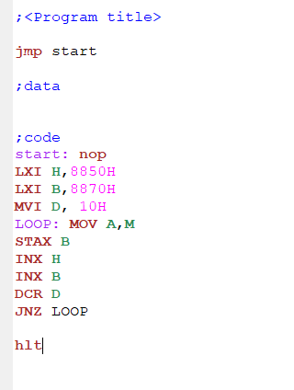

;<Program title>

jmp start

;data

;code

start: nop

LXI H,8850H

LXI B,8870H

MVI D, 10H

LOOP: MOV A,M

STAX B

INX H

INX B

DCR D

JNZ LOOP

Hlt

INPUT OUTPUT

# Screenshot 2023-08-04 010704.png Screenshot 2023-08-04 010742.png

# Q2. 16 Bytes of data are stored in memory location from 8850H To 885FH. Transfer the entire block of data bytes to new memory location starting from 8870H in Reverse Order

## Code

;<Program title>

jmp start

;data

;code

start: nop

LXI H,885FH

LXI D,8870H

MVI B, 10H

LOOP: MOV A,M

STAX D

DCX H

INX D

DCR B

JNZ LOOP

hlt

# 

# INPUT OUTPUT

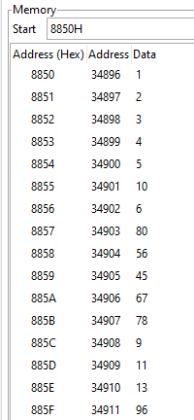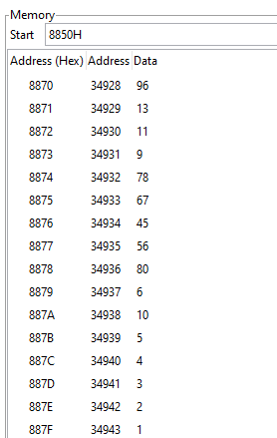

# Q3.Write ALP that will add N numbers of Bytes starting at 8C01.Value Of N is stored in 8C00H. Store the result in 9000H and if carry is present store it at 9001H.

## Code

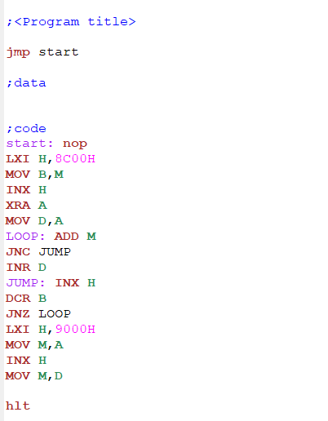

*;<Program title>*

*jmp start*

*;data*

*;code*

*start: nop*

*LXI H,8C00H*

*MOV B,M*

*INX H*

*XRA A*

*MOV D,A*

*LOOP: ADD M*

*JNC JUMP*

*INR D*

*JUMP: INX H*

*DCR B*

*JNZ LOOP*

*LXI H,9000H*

*MOV M,A*

*INX H*

*MOV M,D*

*hlt*

# INPUT OUTPUT

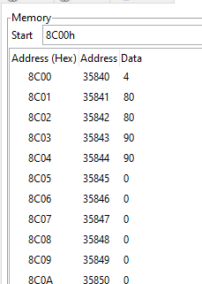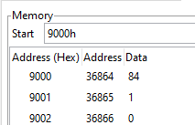

# Q4. Two 8 bit numbers are stored in memory locations 8C00H and 8C01H. Perform Multiplication and store result in 8C02H

## CODE

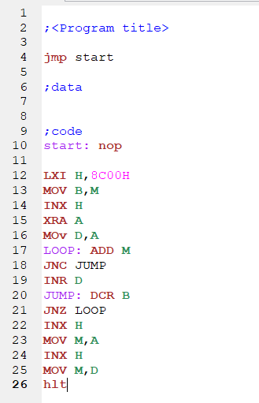

*;<Program title>*

*jmp start*

*;data*

*;code*

*start: nop*

*LXI H,8C00H*

*MOV B,M*

*INX H*

*XRA A*

*MOv D,A*

*LOOP: ADD M*

*JNC JUMP*

*INR D*

*JUMP: DCR B*

*JNZ LOOP*

*INX H*

*MOV M,A*

*INX H*

*MOV M,D*

*hlt*

# INPUT - OUTPUT

